**I am deploying a web server and hosting a website on it by using Linux.**

This is my Virtual Machine.

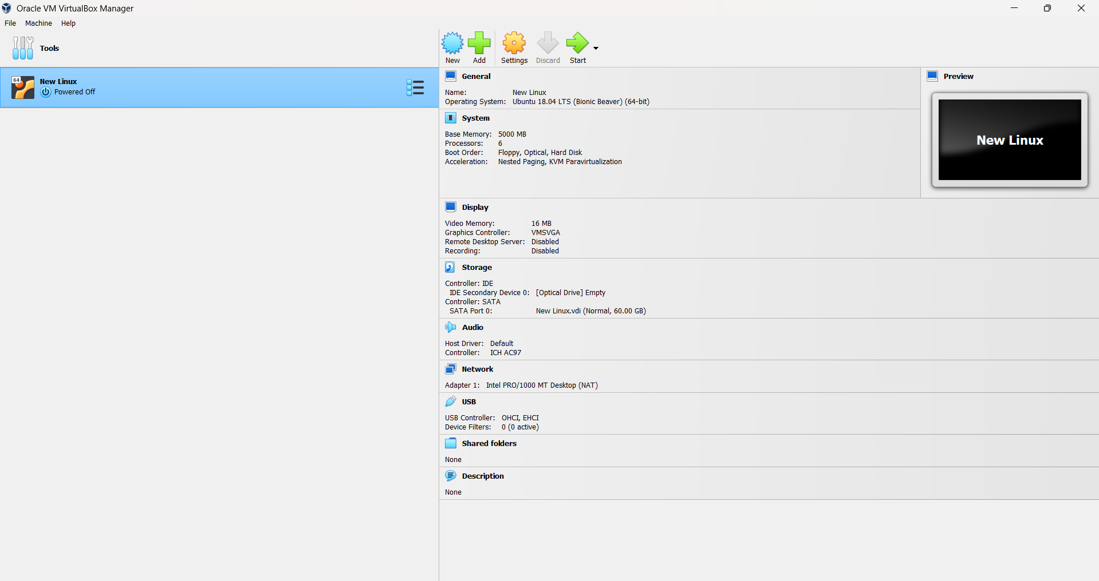

I am using ubuntu for this project.

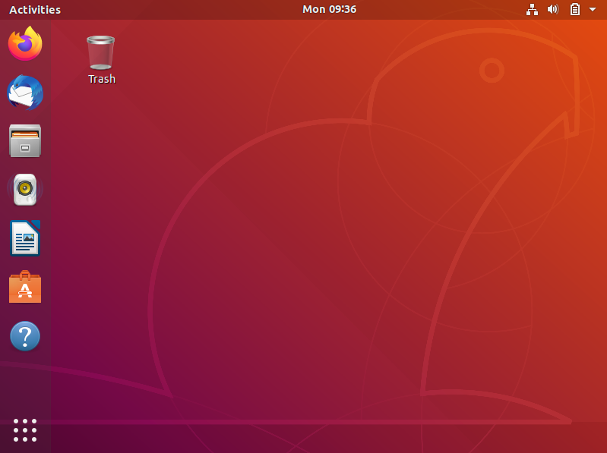

At first, I will deploy a web server on my machine. But before that I have checked my machine for latest software and updates of security patches. I ran “sudo apt update” and “sudo apt upgrade” commands on my terminal for this process.

I am using “apache2” web server for this project because it was one of the most recommended servers for this project.

I am installing “apache2” by running “sudo apt install apache2” command in the terminal.

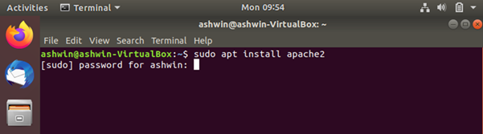

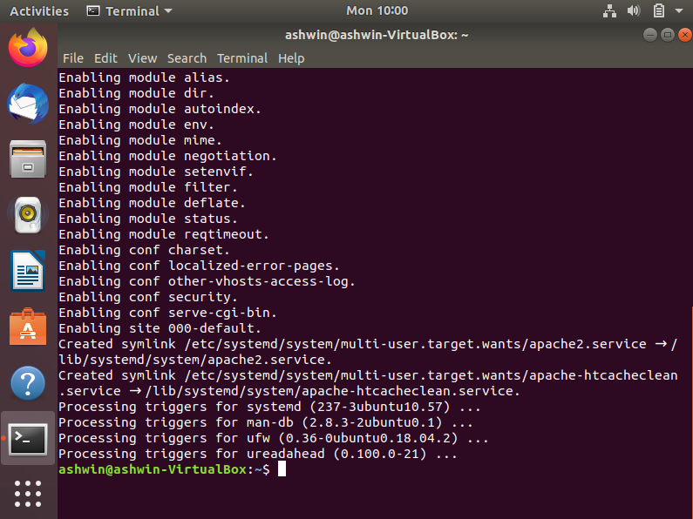

After Installing “apache2” I ran “sudo systemctl start apache2” and “sudo systemctl enable apache2”.

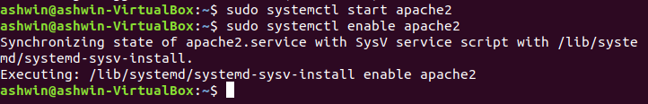

Website files are usually stored in ‘/var/www/html/’ and the main page is ‘index.html’. So, I used “sudo nano /var/www/html/index.html” command for opening the main page and replaced all the sample and default code of html from the page with my own simple html code. I took the help of the internet for this because I am not specialized in html. The hostname or server name is ‘ashwin-linux’. It’s the identity of this website.

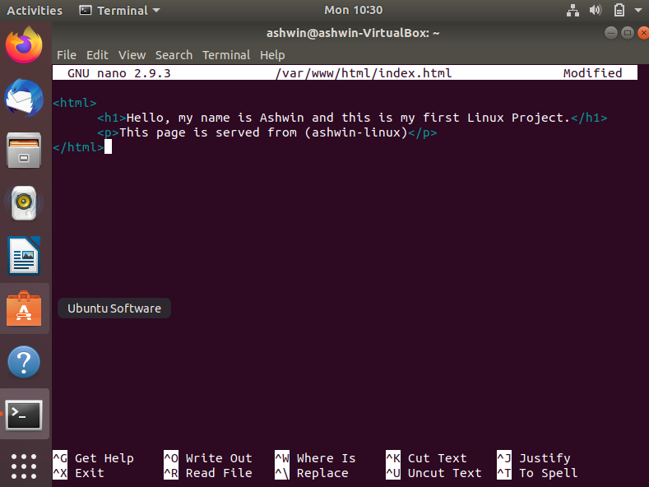

I gave this project a file name called ‘Ashwin1’. So, after running “ls” command it shows the file.

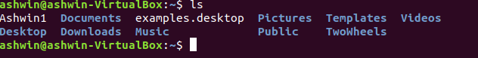

Now I simply opened the browser and typed <file:///home/ashwin/Ashwin1> for opening the file directly as a webpage in the browser.

